**User Guidelines for the Deontic Statement Annotation Tool**

**Introduction**

This tool is designed to help annotators identify obligations, prohibitions, and permissions from UK legislative acts following the provided **Annotation Guidelines**. It provides an interface to systematically **add annotations**, where users can **copy** the relevant legal text, **paste** it into the designated template slots, and, if necessary, **make minimal revisions** to the copied text.

Annotations can be saved and exported when finished. This document provides clear, step-by-step instructions for using the tool effectively.

**Understanding the Template**

Each annotation should fill the following slots:

* **IT IS:** (Mandatory) Choose between OBLIGATORY, PROHIBITED, or PERMITTED.
* **FOR:** (Mandatory) Indicate the **Authority, Person, or Entity** responsible.
* **TO:** (Mandatory) Describe the **Action or Requirement**.
* **2 x WHEN/IF/WHERE, ONLY IF, BEFORE, AFTER, UNLESS:** (Optional) Specify max 2 **conditions** if needed.

**Important:**

* Always prioritize minimal rephrasing for fluency and grammatical correctness.
* Focus only on **regulative norms** (obligations, permissions, prohibitions), excluding definitions or other types of text. The tool is designed to identify *only* regulative norms.

(Reference: Full Annotation Guidelines provided)

**Step-by-Step: How to Use the Tool**

**1. Identifying the Text to Annotate**

* Use the legislative text on the right side of the screen.
* Find a sentence or section that states an obligation, prohibition, or permission.

**2. Filling the Template**

* + **IT IS:**
* Use the dropdown menu to select OBLIGATORY, PROHIBITED, or PERMITTED.
  + **FOR:**
* In the "Authority, Person, Entity" box, paste or rephrase who must (or must not) act.
  + **TO:**
* In the "Action, Requirement" box, paste or rephrase what action must, must not, or can be done.
  + **WHEN/IF/WHERE (Optional conditions – max 2):**
* If the obligation or permission only applies under specific conditions, fill the "Condition details" box under the "WHEN/IF/WHERE" dropdown.
* Use the dropdown to select other types of conditions like ONLY IF, BEFORE, AFTER, or UNLESS if appropriate.
* If no condition applies, leave the two boxes empty (they are optional!).
* The tool allows you to specify a maximum of 2 conditions. If you need to add more than 2 conditions, you will have to do so manually in the final text file.

**3. Adding the Annotation**

* Once the fields are complete, press **"Add Annotation"**.
* The annotation will be added to the export list (visible in the right-side panel when you press “**Show annotations done so far**”; press this button again to hide the list. You can also manually modify the text in the export list).

**4. Exporting Annotations**

* After completing all annotations:
  + Press **"Export Annotations"**.
  + A text file will download containing all saved annotations.

**Important:**

* If you inadvertently close or refresh the tab before exporting, the tool will automatically download the annotations made up to that point (the list you can view by clicking “Show annotations done so far”). This feature is designed to prevent any loss of work.

**Example Walkthrough**

Consider Section 2(1) of the Children Act 1989: “*Where a child’s father and mother were married to, or civil partners of, each other at the time of his birth, they shall each have parental responsibility for the child.*”

You should annotate this text as follows:

* **IT IS:** OBLIGATORY
* **FOR:** a child's father and mother
* **TO:** have parental responsibility for the child
* **WHEN/IF/WHERE:** they were married to, or civil partners of, each other at the time of his birth.

You can, of course, copy and paste from the right side into the slots as shown in the next screenshot, where the text selected on the right is the one to be copied into the “**TO**” slot:

However, occasionally, some minor rephrasing may be required to ensure the text on the left is fluent and readable. For example, since the “**WHEN/IF/WHERE**” slot follows the “**TO**” slot, the text “*a child’s father and mother were not married to, or civil partners of, each other at the time of his birth*” from the right must be rephrased to “*they were not married to, or civil partners of, each other at the time of his birth.*”, i.e., by replacing “*a child’s father and mother*” with the pronoun “*they*”.

**IMPORTANT: Once you have filled the slots, please read through the entire text on the left (“It is obligatory for … to … etc.) to double-check that it reads smoothly.**

When you’re satisfied, click “**Add Annotation**”.

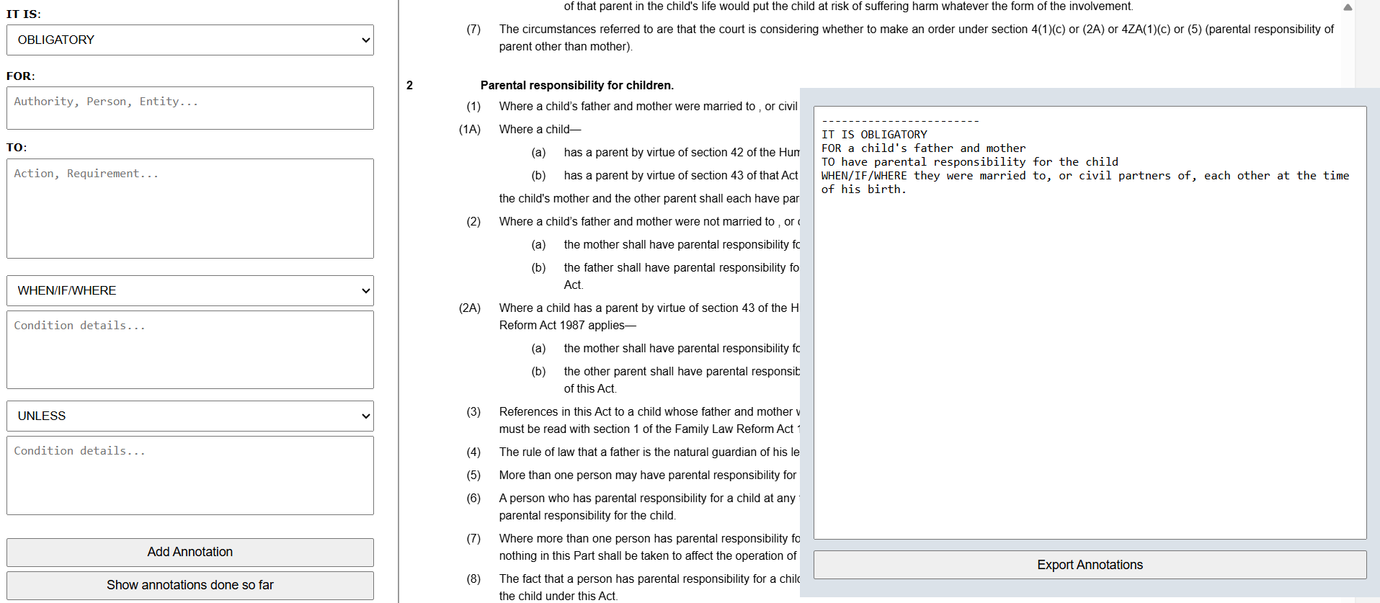You may then view the list of annotations done so far by pressing “**Show annotations done so far**”. Click again this button to close the list.

**Zip package**

Each zip package contains one or more parts or chapters of an act, with multiple sections. When you click “Export Annotation” or close the tab, a .txt file with the same name as the package will be downloaded. Do not change the file name, please return the .txt file via email as it is.

**Best Practices**

* **Fluency Check:**
  + The most important part is that you always double-check the filled template by reading it aloud: “It is obligatory for [X] to [do Y] when [condition].”
  + Make sure it sounds natural and grammatically correct.
* **Minimal Rephrasing:**
  + Change the original legislative text minimally, only to ensure the Fluency Check.
* **Multiple Conditions:**
  + If there are two conditions, use both condition fields (e.g., WHEN/IF/WHERE, UNLESS, ONLY IF, etc.). If there are more than two conditions (which is very rare, but not impossible), modify the export list manually.
* **Avoid Overthinking:**
  + Choose the simplest and most natural interpretation whenever multiple options are correct.

If you have questions, always refer back to the full Annotation Guidelines or ask a project supervisor.

Happy Annotating!